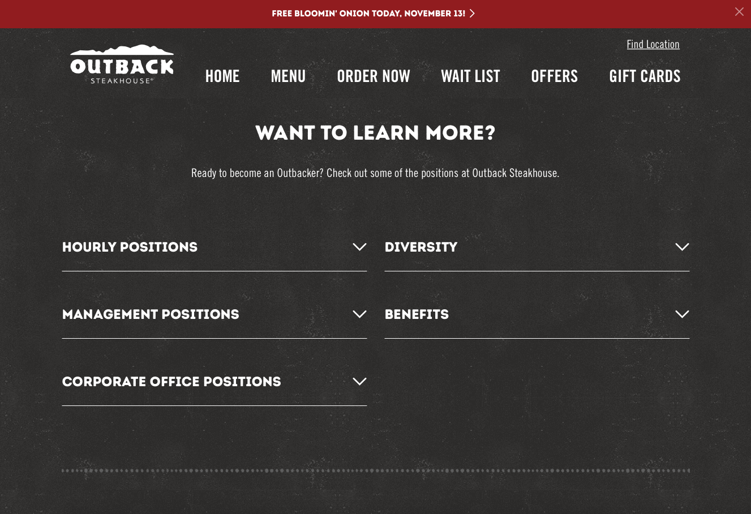

Career search through position & location

Native to outback.com

Figure : Finding career information is native to ouback.com, and searchable by position and location.

\

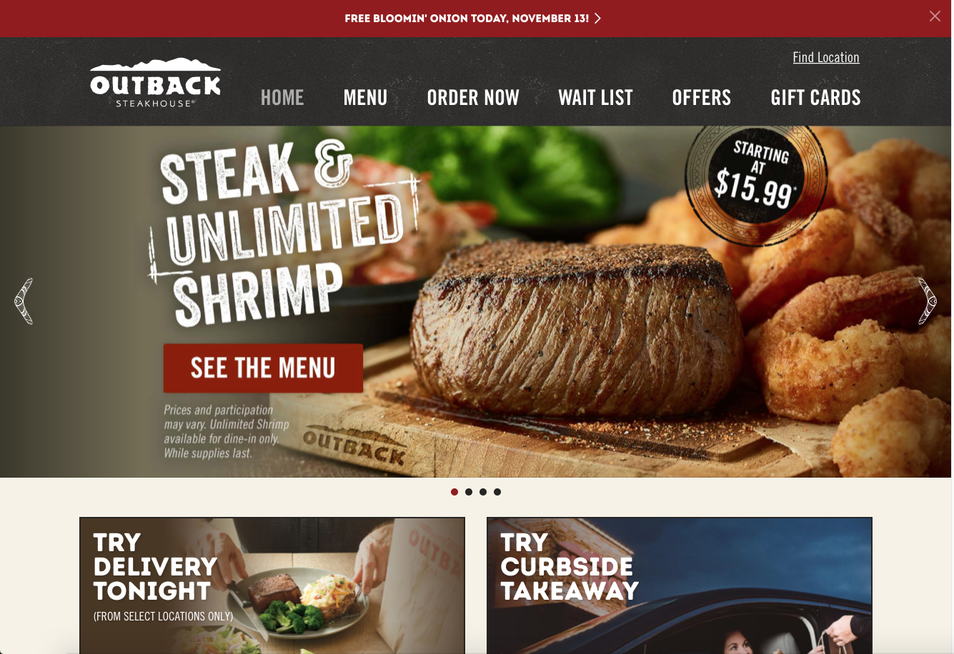

Large navigation bar

Few items in slider, and slider moves slowly

Figure : Home page isn’t overly busy, and color scheme roughly follows 60-30-10 rule. Navigation bar is large and informative, and slider is slow moving with few images.

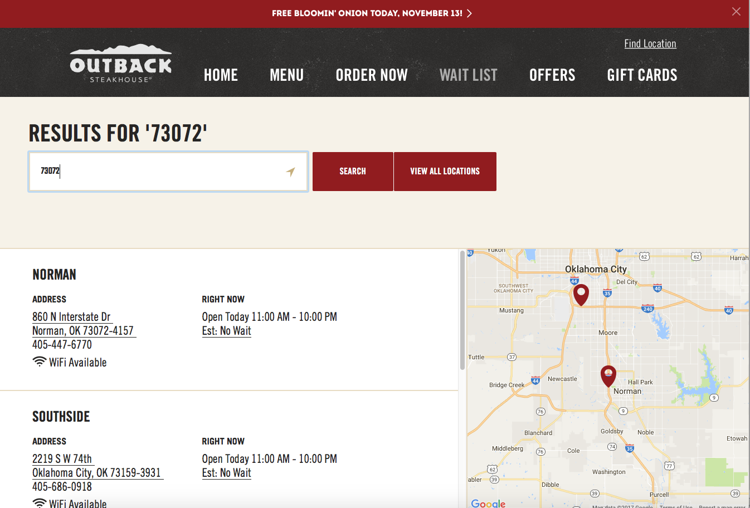

Search for specific zip code, rather than a drop down

Contact info and address easily viewable

Map available showing exact location

Figure : Searching for call ahead information is easily done on Outback’s website through their “Wait List” page.

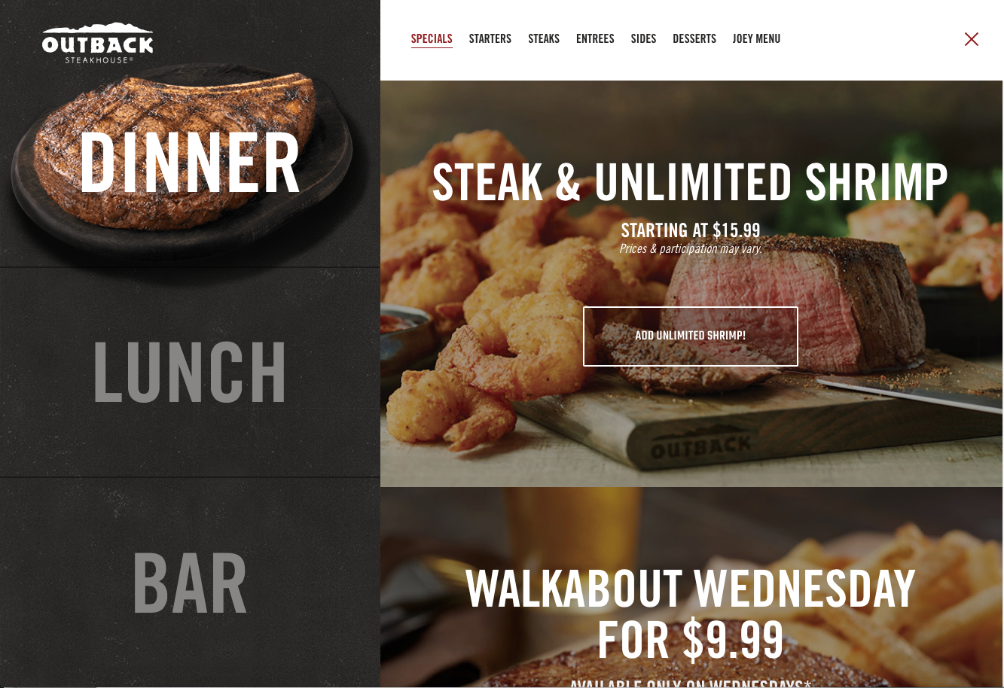

Easily navigable and informative menu headings

Menu is native to website, with large navigation buttons

Figure : The menu available on Outback Steakhouse’s website is easily navigable, shows prices and menu items clearly, and is native to the original website (doesn’t require redirection to another site / downloading a PDF)